Create and configure Virtual Networks
What we accomplished:
- Created a virtual network
- Created a subnet
- Configure vnet peering
Portal.azure.com -- type “Virtual Networks” Select “Create”
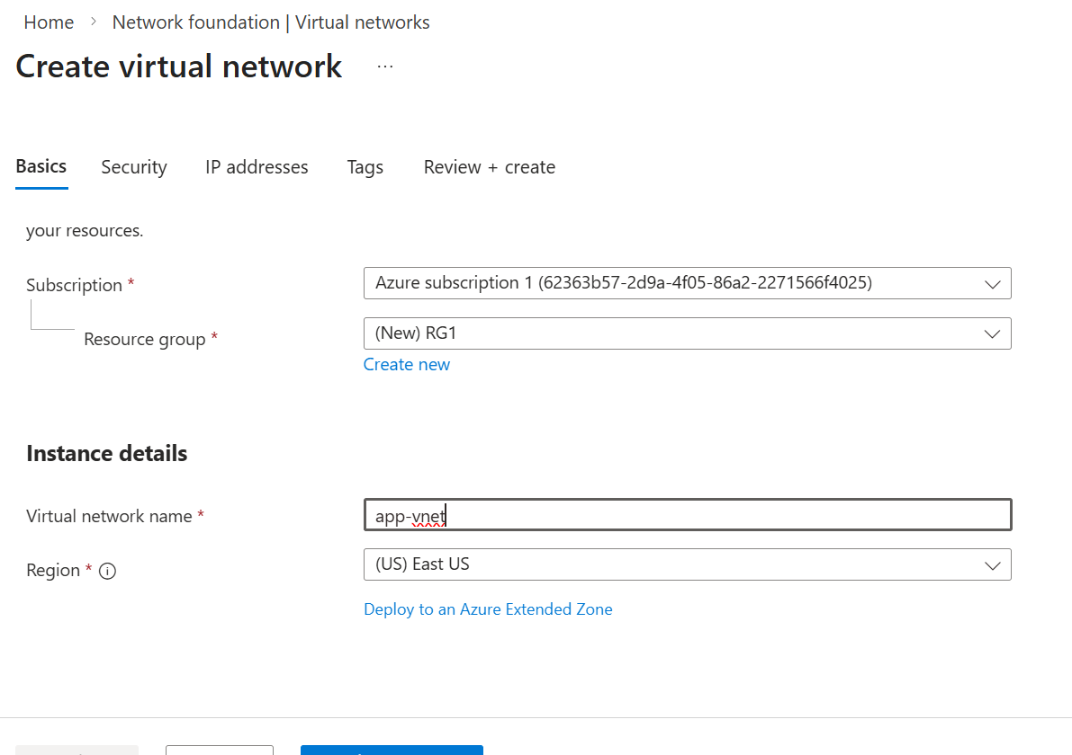

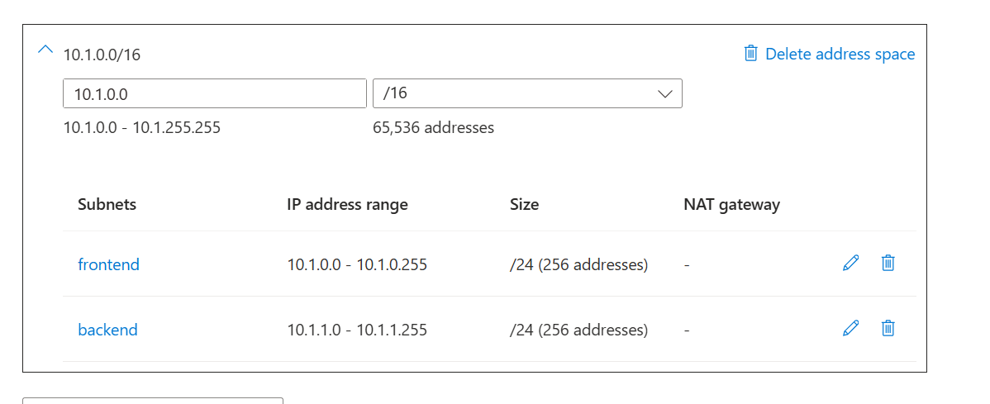
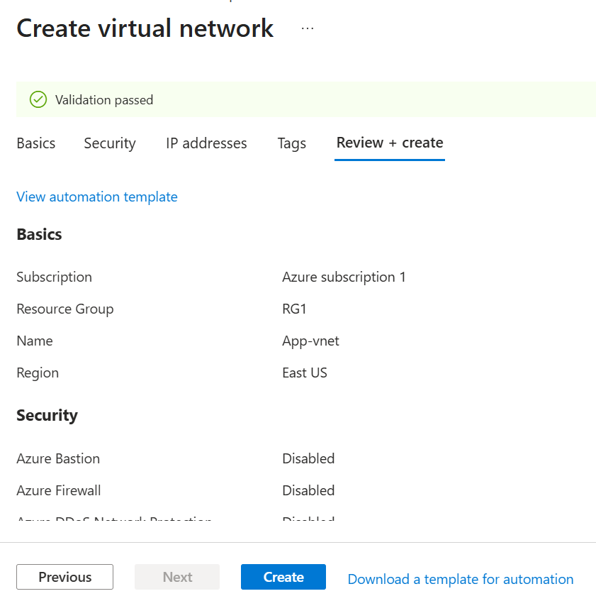

Change Subnet Purpose from Default to Azure Firewall (Note: name automatically changes to AzureFirewallSubnet)
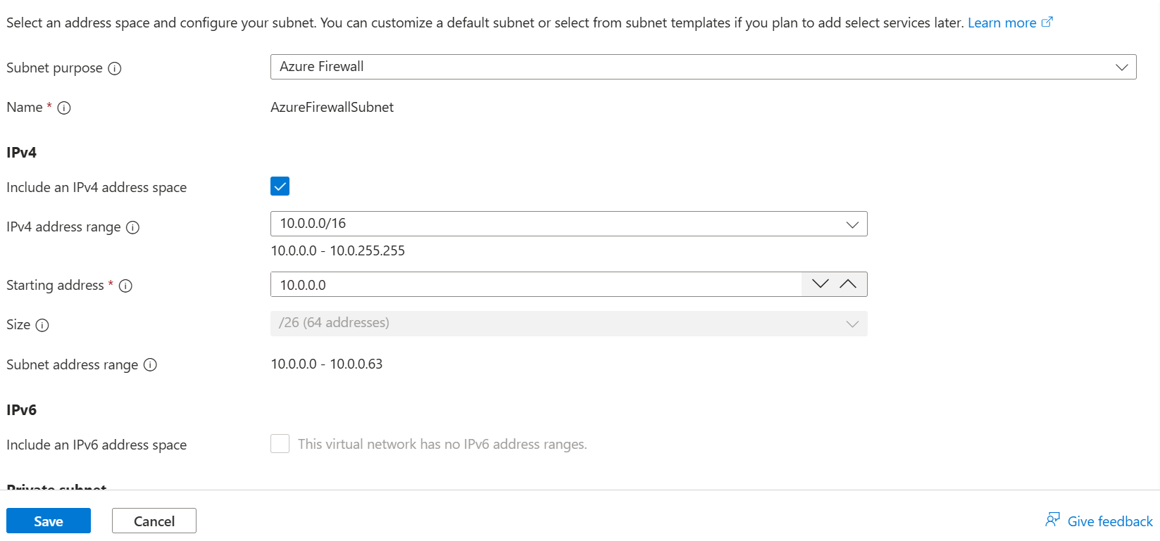

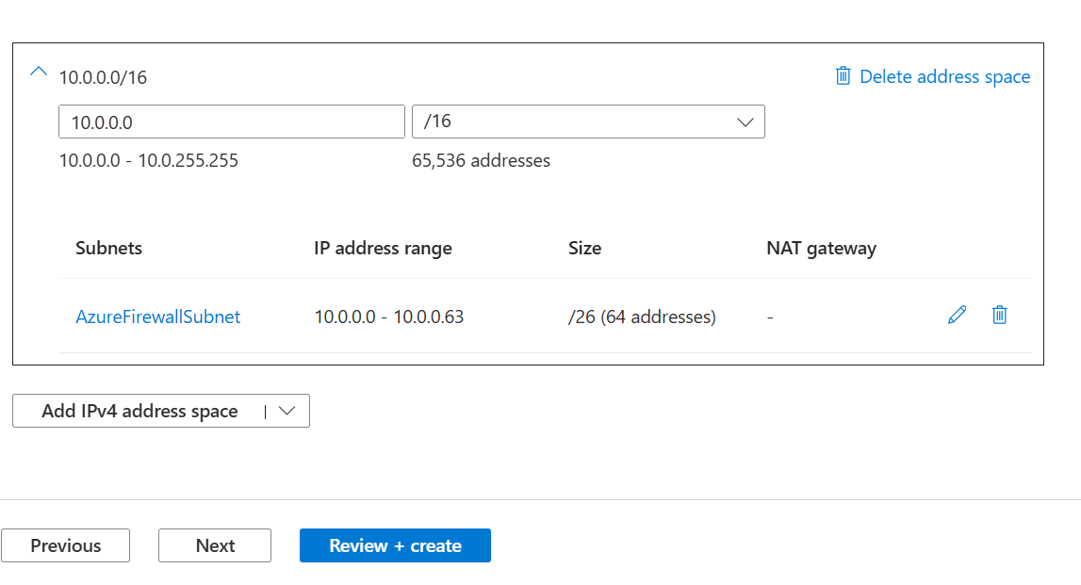

Select Review + create and wait for vnet to deploy. Search Virtual networks to verify the two virtual networks made.

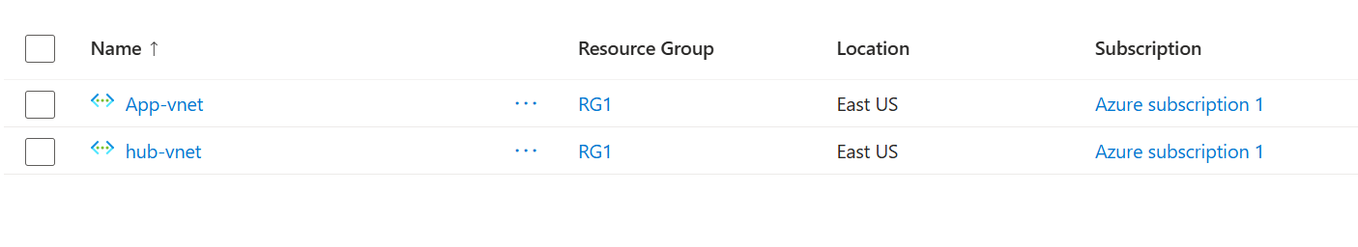

Configure a peer relationship between the virtual networks
Search for and select App-vnet. In the settings select peerings
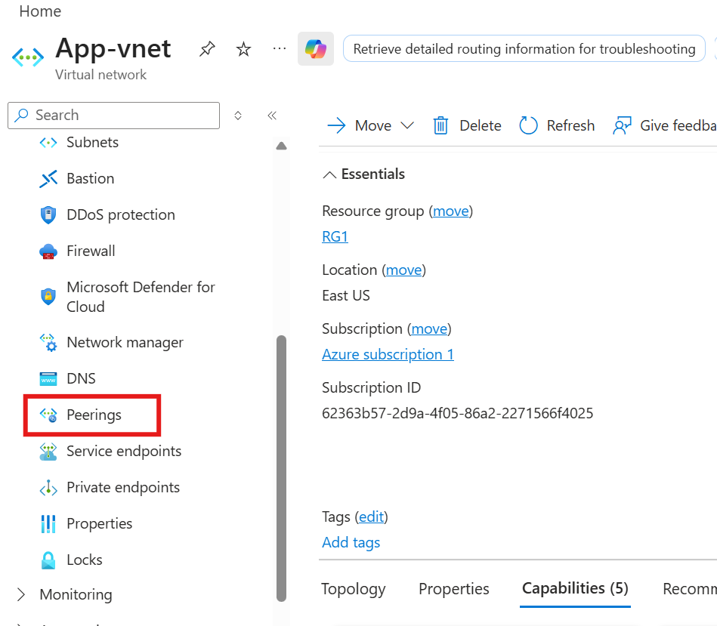

Select Add
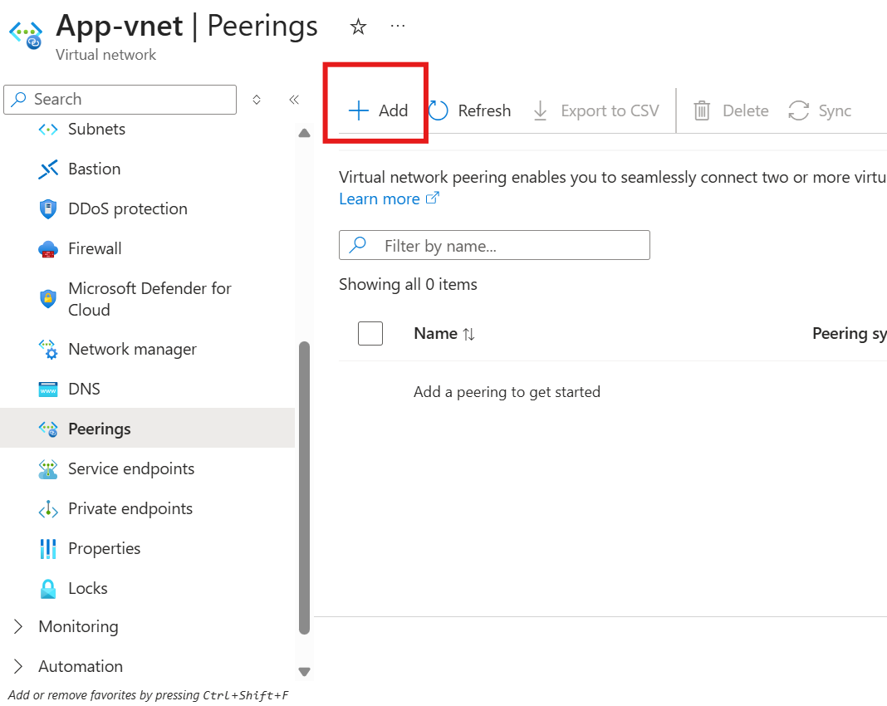

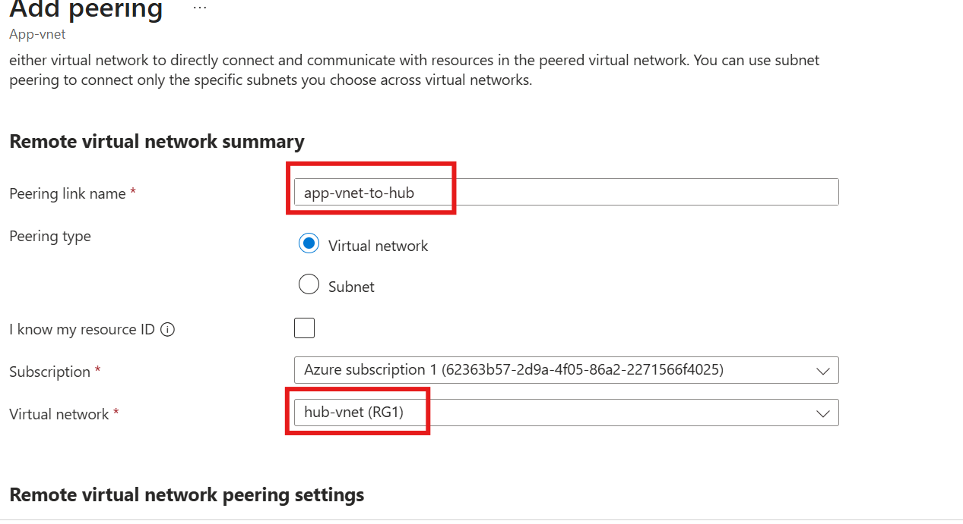

Under Local virtual network peering link name add: hub-to-app-vnet and select Add

Vnet Peering has been added successfully:
